**DigiTac Fabrication Notes**

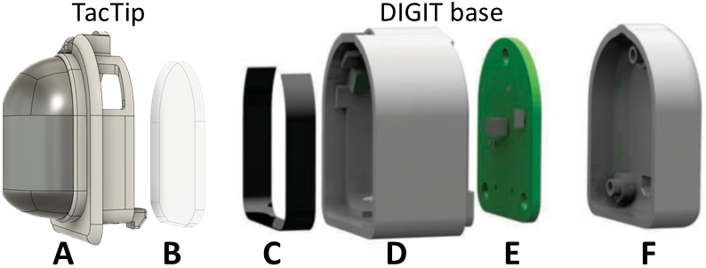

These instructions assume you have an assembled DIGIT base (parts C-F above) and you have removed the elastomer front component (attached by a single retainer screw).

Parts required are:

* 3D-printed TacTip front part to fit on the DIGIT
* Acrylic window
* 3D-printed plug

Follow these instructions for the open-TacTip with the corresponding parts of this assembly

<https://softroboticstoolkit.com/tactip/fabrication/flesh>